**Rpm 方式方式安装 Artifactory 单点**

**1. 下载安装包(页面流程)**

1) 安装包下载地址：<https://jfrog.com/download-jfrog-platform/>

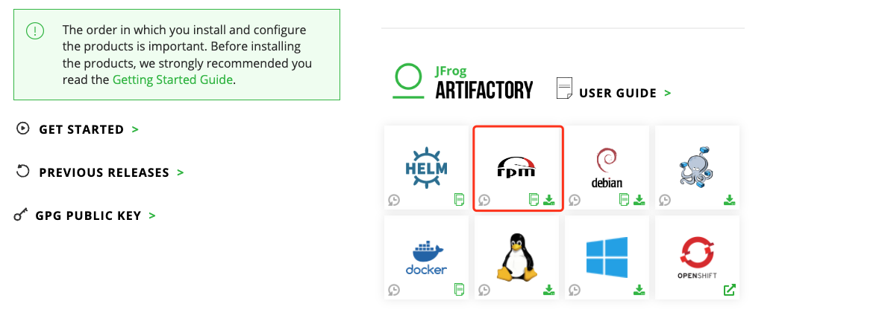

您可下载最新版或指定历史版本（建议安装最新版）。

2) 您也可在服务器上直接下载安装包，以 7.71.11 为例:

| $ wget https://releases.jfrog.io/artifactory/artifactory-pro-rpms/jfrog-artifactory-pro/jfrog-artifactory-pro-7.71.11.rpm |
| --- |

**2. 安装**

| $ yum install -y jfrog-artifactory-pro-7.71.11.rpm |
| --- |

默认安装目录说明：

应用目录：/opt/jfrog/artifactory/app/

配置目录：/opt/jfrog/artifactory/var/

**3.配置数据库**

(可选。以 MySQL 为例, 其他配置参考 [**《Artifactory 安装 - 数据库配置》**](https://www.jfrogchina.com/docs/artifactory-install-db/))

如当前没有数据库，通过如下语句创建：

| CREATE DATABASE artdb CHARACTER SET utf8 COLLATE utf8_bin;  CREATE USER 'artifactory'@'%' IDENTIFIED BY 'password';  GRANT ALL on artdb.* TO 'artifactory'@'%';  FLUSH PRIVILEGES; |
| --- |

下载 MySQL jdbc jar 包，并拷贝至 /opt/jfrog/artifactory/var/bootstrap/artifactory/tomcat/lib/:

(下载地址：<https://dev.mysql.com/downloads/connector/j/>), 如：

| $ wget <https://downloads.mysql.com/archives/get/p/3/file/mysql-connector-java-8.0.13.tar.gz>  $ tar zxf mysql-connector-java-8.0.13.tar.gz  $ cp mysql-connector-java-8.0.13/mysql-connector-java-8.0.13.jar /opt/jfrog/artifactory/var/bootstrap/artifactory/tomcat/lib/ |
| --- |

修改数据库配置：

编辑配置文件 /opt/jfrog/artifactory/var/etc/system.yaml, 添加 database 部分，完整示例如下:

| configVersion: 1  shared:  node:  id: "art1"  ip: "192.168.56.13"  database:  type: mysql  driver: com.mysql.jdbc.Driver  url: "jdbc:mysql://**192.168.56.13:3306**/**artdb**?characterEncoding=UTF-8&elideSetAutoCommits=true&useSSL=false"  username: **artifactory**  password: **password** |
| --- |

说明：

shared.node.id: 自定义，如 art1, art2…

shared.node.ip: 本机 IP, 如 192.168.56.13

**4. 配置存储**

(可选。以 本地存储 为例, 如不配置，默认存储在安装目录 /opt/jfrog/artifactory/var/data/，其他存储方式请参考[**《Artifactory 安装 - 存储配置》**](https://www.jfrogchina.com/docs/artifactory-install/))

编辑配置文件 /opt/jfrog/artifactory/var/etc/artifactory/binarystore.xml, 添加以下部分:

| <?xml version="1.0" encoding="UTF-8"?>  <config version="1">  <chain template="file-system"/>  <provider id="file-system" type="file-system">  <fileStoreDir>**/var/opt/jfrog/data/filestore**</fileStoreDir>  </provider>  </config> |
| --- |

说明：

fileStoreDir: 二进制文件存储实际目录, 请根据实际路径进行配置

配置后，因 Artifactory 默认以 artifactory 用户运行，需对存储目录授权：

| $ chown -R artifactory:artifactory /opt/jfrog/artifactory/var/data/ |
| --- |

**5. 启动 Artifactory**

| systemctl start artifactory |
| --- |

**6. 检查日志**

| tail -f /opt/jfrog/artifactory/var/log/console.log |
| --- |

日志有如下输出，启动成功：

| ###############################################################  ### All services started successfully in 50.958 seconds ###  ############################################################### |
| --- |

**7. 访问页面**

<http://192.168.56.13:8082>

默认用户名密码: admin/password



提示：

进入页面后需填写 License，您可联系 JFrog 商务以获取。